POZ-DBA/09-Z3 |  |  |  |  |  |  |  |  | Date of revision: |  |  |  |  |  |  |  | Date of issue of the form: 30-09-2022
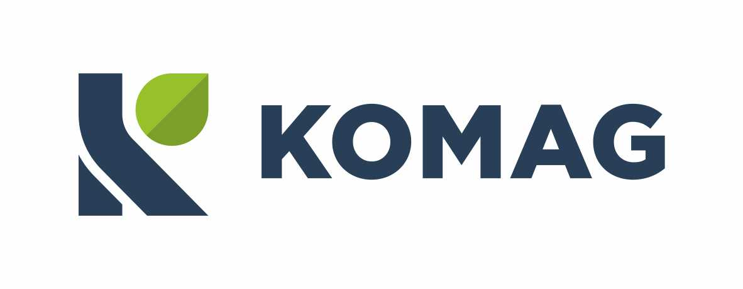  Zakład Badań Atestacyjnych Jednostka Certyfikująca |  |  |  |  |  |  |  |  | APPLICATION  FOR A CERTIFICATE OF RECEIPT AND RETENTION OF TECHNICAL DOCUMENTATION
in accordance with the procedure set out in Article 13 para. 1(b)(ii) of Directive 2014/34/EU of 26 February 2014
 |  | new certificate
 |  | renewal of certificate no.: ……………………………………………..
 |  | extension of the scope of certificate no.: …….……………………………………….

I. Name, address, status of the Applicant:
 |  |  |  | Manufacturer |  |  |  |  |  |  |  |  |  |  | Authorised representative *
 |  |  |  |  |  |  |  |  |  |  |  |  |  |  | Where the application is lodged by an authorised representative, the name and address of the Manufacturer shall be given:
* ‘authorised representative’ means any natural or legal person established within the Union who has received a written mandate from a manufacturer to act on his behalf in relation to specified tasks. In the case of an authorised representative, the relevant documents proving the authorisation shall be attached.
II. Product name, type, versions:
III. Ex marking:
IV. Manufacturing:
 |  | Unit manufacturing
 |  | Series manufacturing. Planned manufacturing period: |  |  |  |  |  |  |  |  |  |  | years
Following registration of the application and verification of its validity, a written confirmation will be issued specifying the conditions for the retention of the documentation covered by this application.
V. Documentation:
paper |  |  |  |  |  |  |  |  |  |  |  |  |  | electronic

VI. Statements by the Applicant:
- I order the technical documentation of the product to be retained against payment for the declared period of manufacture and for a period of 10 years after the end of manufacture and undertake to comply with the requirements indicated in the order confirmation and in this application:
- I undertake to pay the following fees:
- For the storage of technical documentation - a fee of PLN 120 + VAT at the rate in force on the day of issuing the VAT invoice, for each declared year of manufacturing - the fee is collected in advance for the whole period and is not refundable in case of discontinuation of manufacturing earlier than in the declared period or in case of withdrawal of the certificate.
- For storing the technical documentation for a period of 10 years after the end of manufacturing - a one-off fee of PLN 1200 + VAT at the rate applicable on the day of issuing the VAT invoice.
- For the extension of the certificate - one-off fee for each extension in the amount of PLN 200 + VAT as applicable on the day of issuing the VAT invoice.
- For the extension of the validity of the certificate - a fee of PLN 200 + VAT at the rate applicable on the day of issuing the VAT invoice, for each declared year of the extension.
The above fees are payable in advance. The charge invoice will be issued by ITG KOMAG on the basis of the work acceptance protocol.
- The technical documentation complies with the requirements of Module A: Internal production control - Annex VIII of Directive 2014/34/EU
- I declare that:
- I have the right to use the technical documentation that identifies the product(s) covered by this application
- This application for the above mentioned product has not been lodged with any other notified body.
- The submitted technical documentation was neither prepared nor consulted by ITG KOMAG
 |  |  | / First name, surname / |  |  |  |  |  |  |  | / signature / |  |  |  |  |  |  |  |  |  |  | /date/
Please be informed that the administrator of the personal data provided in the Application Form is ITG KOMAG. Personal data will be processed for purposes related to the implementation of the certification process / conformity assessment / issuing an opinion. In order to obtain full information please read the information clause placed on our website http://komag.eu/kontakt/polityka-prywatnosci

VII. Review and registration of the application (to be completed by Notified Body)
Review:
The application contains sufficient information to carry out the process
The product, which is the subject of the application, is subject to the requirements of the procedure set out in Article 13 para. 1(b)(ii) of Directive 2014/34/EU of 26 February 2014.
Decision:
Registration of the application and execution of the process
Refusal to process
Application no.

/date, signature, stamp of the person authorised to receive the application/

The technical documentation shall specify the applicable requirements and cover, as far as relevant for the assessment, the design, manufacture and operation of the product. The technical documentation shall contain at least the following elements: (a) a general description of the product, (b) conceptual design and manufacturing drawings and schemes of components, sub-assemblies, circuits, etc., (c) descriptions and explanations necessary for the understanding of those drawings and schemes and the operation of the product, (d) a list of the harmonised standards applied in full or in part the references of which have been published in the Official Journal of the European Union and, where those harmonised standards have not been applied, descriptions of the solutions adopted to meet the essential health and safety requirements of this Directive, including a list of other relevant technical specifications applied. In the event of partly applied harmonised standards, the technical documentation shall specify the parts which have been applied, (e) results of design calculations made, examinations carried out, etc., and (f) test reports.

