PO-DBA/16-Z1 |  |  |  |  | Date of revision: 1-02-2024 |  |  |  |  |  |  |  |  |  |  |  |  |  | Date of issue of the form: 30-09-2022
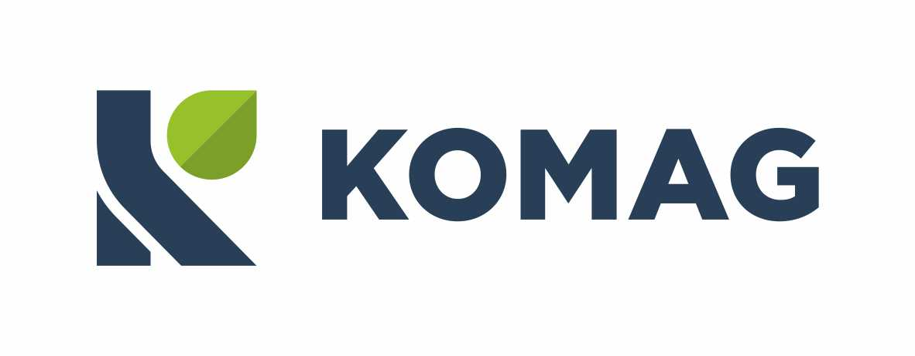  Zakład Badań Atestacyjnych Jednostka Certyfikująca |  |  |  |  | APPLICATION  FOR PRODUCT CERTIFICATION IN A VOLUNTARY AREA / ISSUE OF AN OPINION
 |  | Certification of conformity
 |  | Certification of the registered trademark "B"
 |  | Issuing of the opinion " Test results"
Applies to product: |  |  |  | new product |  |  |  |  |  |  |  | product modifications (Certificate No )
- Name, address: (physical site address(es), manufacturing site)
Applicant * |  |  |  |  |  |  |  |  |  |  |  |  | Manufacturer
* To be filled in if the Applicant is not the Manufacturer.

- General information concerning the Applicant:
(human and technical resources, including laboratories and/or technical resources and links within the larger corporation)
- Information on all subcontracted processes used by the Applicant:
(concerns processes affecting conformity with requirements)
- Product name, type, versions:
- Information required for the initial assessment and surveillance activities:
Certification programme type according to PN/EN ISO/IEC 17067:2014-01 |  |  |  |  |  |  |  |  |  | 1a |  |  |  |  | 1b |  | 3 |  |  | „N” : |  |  |  |  | 11 |  | 8
 |  |  |  |  |  |  |  |  |  |  |  |  |  |  | 1b |  | 3 |  |  |  |  |  |  |  | Znak B |  | 9a
Production: |  |  |  |  |  |  |  |  |  |  | Unit production |  |  |  |  |  |  |  |  |  |  |  | Series production
Additional information (such as contact persons):
- Confirmation of conformity with:
- Declarations by the Applicant:
- I agree to comply with the certification requirements /concerning the issuing of the opinion ** and to provide all information required for the assessment of the products.
- The technical documentation complies with the requirements of item X of this application.
- I declare that:
- the application for certification has not been submitted to another certification body **
- the application for an opinion on the product approval has not been submitted to another certification body **
- I have the right to use the technical documentation that identifies the product(s) covered by this application
- the submitted technical documentation was neither prepared or consulted by ITG KOMAG
** Delete if not applicable
 |  |  | / First name, surname / |  |  |  | / signature / |  |  |  |  |  |  |  |  |  |  |  |  |  |  |  |  | /date/
Please be informed that the administrator of the personal data provided in the Application Form is ITG KOMAG. Personal data will be processed for purposes related to the implementation of the certification process / conformity assessment / issuing an opinion. In order to obtain full information please read the information clause placed on our website http://komag.eu/kontakt/polityka-prywatnosci
- Submission of the application by a letter of commission:
 |  |  | / Letter no. / |  |  |  | / Name of ordering person / |  |  |  |  |  |  |  |  |  |  |  |  |  |  |  |  | /date/

PO-DBA/16-Z1 |  | Date of revision: |  |  | Date of issue of the form: 30-09-2022
- Registration of the application (to be completed by the Certification Body)
Application No.

 | / First name, surname / |  |  | / signature / |  |  | /date/
- Technical documentation:
The technical documentation shall ensure unique identification of the product(s) submitted for certification and shall be in accordance with the requirements of normative standards/documents mentioned in item VI (if they provide requirements for the content of the documentation).
Issuing of opinions on products approved for use in mining plants
Technical documentation of products approved for use in mining plants, by decision of the President of the State Mining Authority, should be in accordance with Article 113(7) of the Act of 9 June 2011. - Prawo geologiczne i górnicze (Journal of Laws of 2020, item 1064, as amended)

