https://doi.org/10.32056/KOMAG2023...
Title, Verdana 14 pt, bold
Received: date
Accepted: date
Published online: date
Author’s affiliations and addresses:  ¹ Full address of the first author, including country  ¹ ORCID number  ² Full address of the second author, including country  ² ORCID number  * Correspondence:  e-mail:  tel.: (optional; include country code) | Author’s full name and surname ^{1*}, full name and surname of the co-author ²  Abstract:  The abstract text should be formatted using 10-point Times New Roman and single spacing. The abstract should give readers concise information about the content of the paper and indicate the main results obtained and conclusions drawn. The abstract is not part of the text and should be complete in itself; no table numbers, figure numbers, references or displayed mathematical expressions should be included. It should be suitable for direct inclusion in abstracting services and should not normally exceed 100-300 words. Since contemporary information-retrieval systems rely heavily on the content of titles and abstracts to identify relevant papers in literature searches, great care should be taken in constructing both.  Keywords: Authors should provide 4 to 6 keywords, which can be used for indexing purposes
- Introduction
The paper should contain 6-10 pages. The main text should be written with single line spacing, paragraph spacing: after 6 pt, alignment: justify. The body of the paper should be divided into chapters including a description of specific problems, questions or tasks, e.g.: An introduction should include general information concerning the main research problems, the main target of the paper and the methodology used in the problem solving process.
Please use the following page setup measurements:

Margin | A4 ONLY – DO NOT USE US LETTER
Top | 2.5 cm
Bottom | 2.5 cm
Left | 2.5 cm
Right | 2.5 cm

It is vital that you do not add any headers, footers and page numbers to your paper; these will be added during the production process at KOMAG.
The main text should contain the following sections:
- Introduction
The introduction should briefly place the study in a broad context and highlight why it is important. It should define the purpose of the work and its significance. The current state of the research field should be carefully reviewed and key publications cited.
- Materials and Methods
The Materials and Methods should be described with sufficient details to allow others to replicate and build on the published results. If article is a review article (does not include laboratory test results), should be presented the state of knowledge in a given field on the basis of current literature.
- Results
This section may be divided by subheadings. It should provide a concise and precise description of the experimental results, their interpretation, as well as the experimental conclusions that can be drawn.
- Discussion
Authors should discuss the results and how they can be interpreted from the perspective of previous studies and of the working hypotheses. The findings and their implications should be discussed in the broadest context possible. Future research directions may also be highlighted.
- Conclusions
This section is not mandatory but can be added to the manuscript if the discussion is unusually long or complex.
- Patents (This section is not mandatory but may be added if there are patents resulting from the work reported in this article).
Acknowledgments (optional)
References
2. Text, font
Chapter (and subchapter) titles should be typed using 12 pt Times New Roman (paragraph spacing before 12 pt, after 6 pt), bold, single line spacing.
2.1. Formatting the author’s name, affiliations and keywords
The author’s name, affiliations and keywords should be typed using 10 pt Times New Roman (Paragraph spacing: before 0 pt, after 6 pt) with single line spacing. Only for author’s names and surnames use bold (author’s name in capital letters). Please provide e-mail address only for the corresponding author.
2.2. Formatting the main text
The text in the chapter should be typed using Times New Roman fonts size 11, with a section incision 0.5 cm. Figures and tables should be numbered continuously. The copy-ready quality of the pictures is expected. The captions and legends should contain all the information necessary for a clear understanding of figures and tables.
3. Figures and tables
All figures, charts, schematics, and photographs should be named as figures in the text and numbered consecutively with Arabic numerals. Each figure should have a brief caption describing it and, if necessary, a key to interpret the various lines and symbols on the figure.
All objects used in one figure should be grouped (the resolution of greyscale images, min. 400 dpi, color images min. 300 dpi). Drawings (figures, charts) should be prepared with minimum line weight 1pt. Accepted image file formats are: JPEG, TIFF, PDF. The figures should be horizontally centered.

Example:
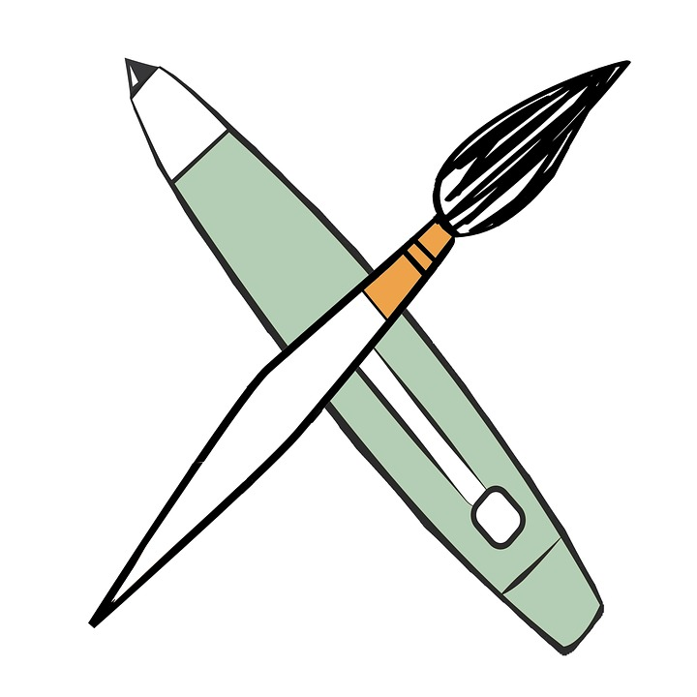
Fig. 1. Title of the figure (11 pt Times New Roman) [the reference number]

Tables should also be numbered (1), (2) with Arabic numerals. Tables should be horizontally centered.

Example:
Table 1. Title of the table [the reference number]
Item | Heading  (Times New Roman 11, interline 1.0, bold) | Text
Item | Heading  (Times New Roman 11, interline 1.0, bold) | Text | Text | Text
1 | text | text | text | text
2 | text | text | text | text
3 | text | text | text | text
4. Equations
Equations should be numbered (1), (2). Do not set them in bold type. Please ensure that subscripts and superscripts are clearly legible. Equations should be placed in separate paragraphs. Formula should be typewritten (use, e.g., Microsoft Equation Editor). Equations number should be aligned to the right margin. Explanation of the marks used in the equation should be given after the equation.
Example:
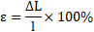 | (1)
where:
ε | – | the relative elongation of the rope, %,
ΔL | – | elongation of the rope, m,
l | – | the length of the working rope, m.
5. Conclusions
Text …
6. Patents
Not mandatory.
Acknowledgements
This section is optional.
References
10 pt Times New Roman (before 0 pt, after 6 pt), single line spacing, alignment: justify
For example:
Kędziora A.: Eksploatacja szybowych urządzeń wyciągowych (Exploitation of shaft hoisting equipment). Katowice: Wydawnictwo Śląsk 1983. ISBN 8321603610
Ramirez C., Federman D., Kirsner R.: Skin cancer as an occupational disease: the effect ultraviolet and other forms of radiation. Int J Dermatol 2005, 44: 95-100. DOI: 10.1111/j.1365-4632.2005.02301.x
https://www.sterilsystems.at/en.html [accessed: 01.05.2021]

The full list of publications used by the author must be presented at the end of the paper: do not cite in footnotes. The references must be presented in chronological order.

Guidelines for authors on references:
http://komag.eu/images/maszynygornicze1/MM2020/Bibliography2020.pdf

